**Practical No 7**

**Aim:** Creating an Excel Pivot Table and Pivot Chart by using the OLAP cube data.

**Solution:**

1. Open MS-Excel. Click on Data Menu.

2. Go to From Other Sources.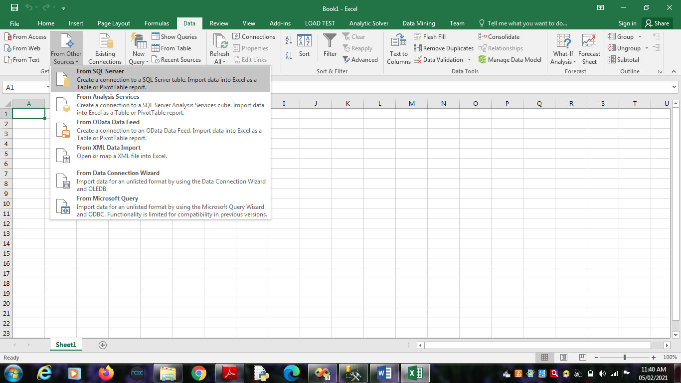

2.1. From SQL Server -> Type Server name as “.”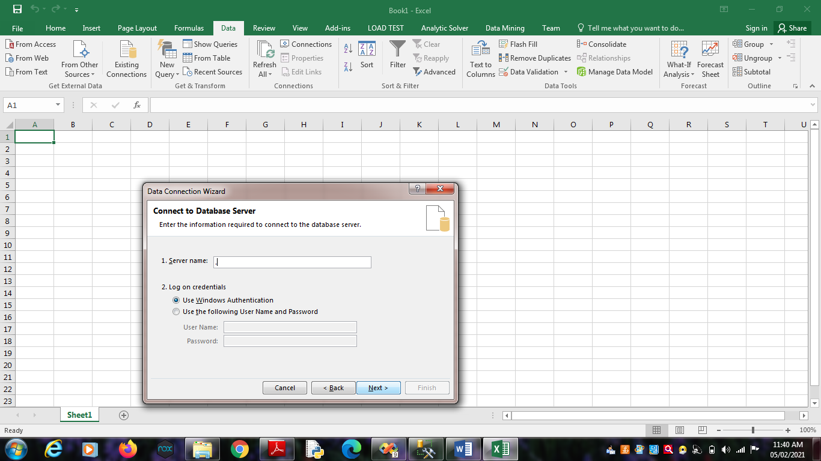

Click on Next.

Choose SQL Database -> “SalesProduct”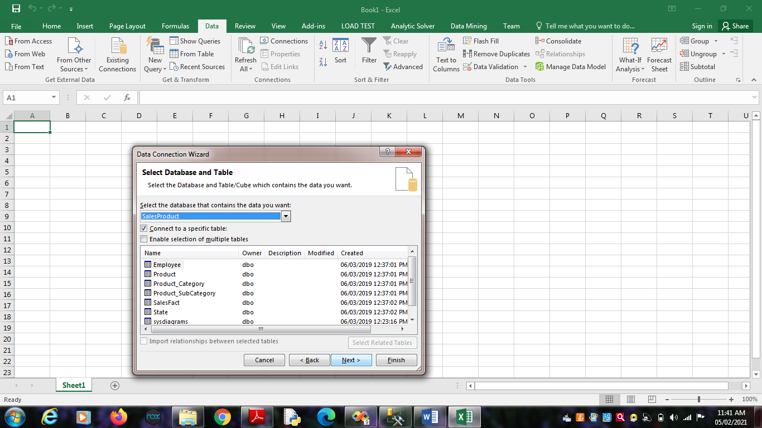

Click on Finish.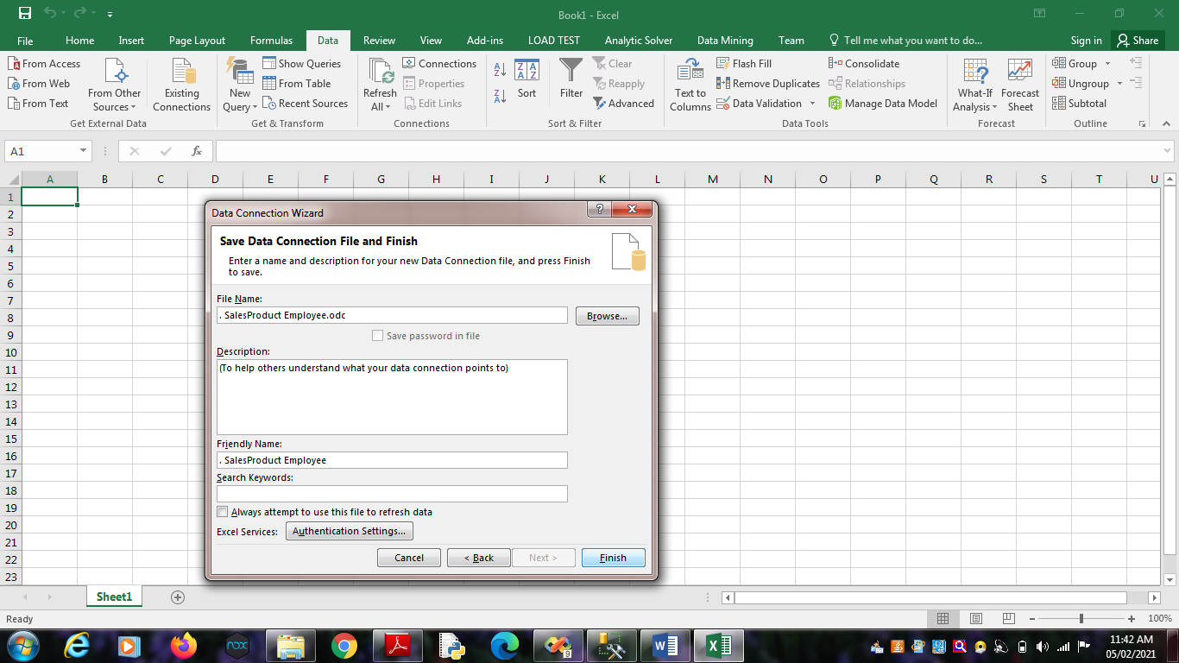

Click on OK.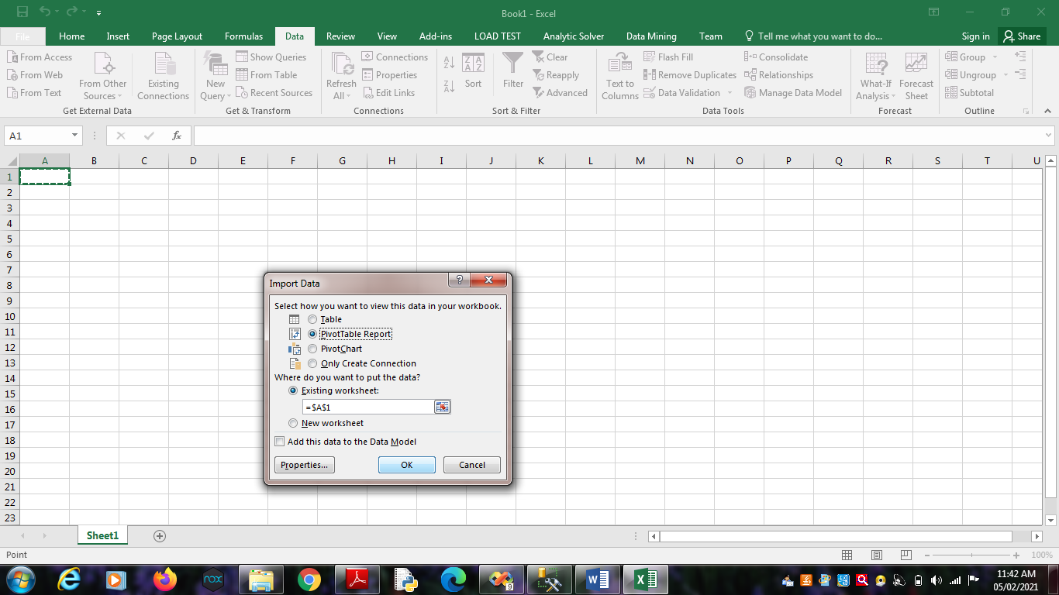

2.2. From Analysis Services -> Type Server name as “.”

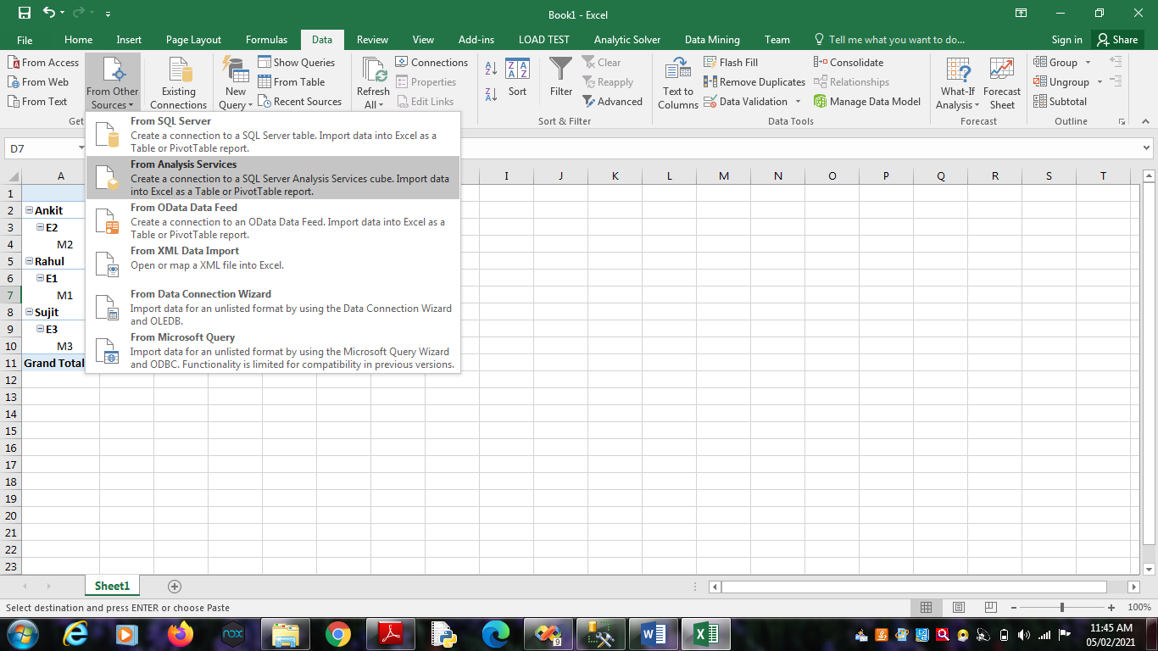

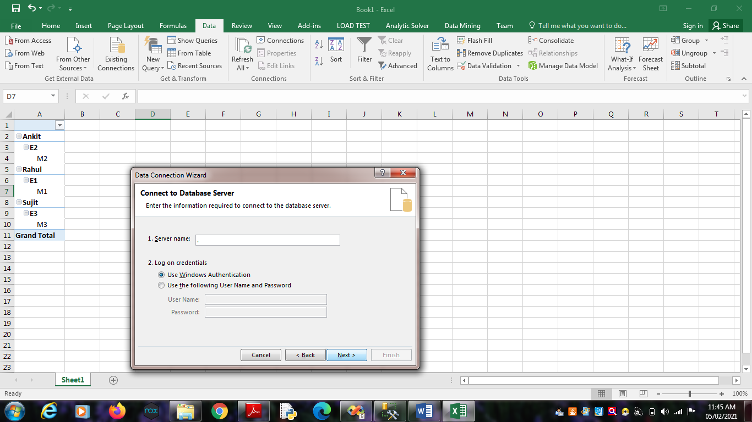

Click on Next.

Choose Analysis Database as “SalesProduct_BIPrj”. Click on

Next.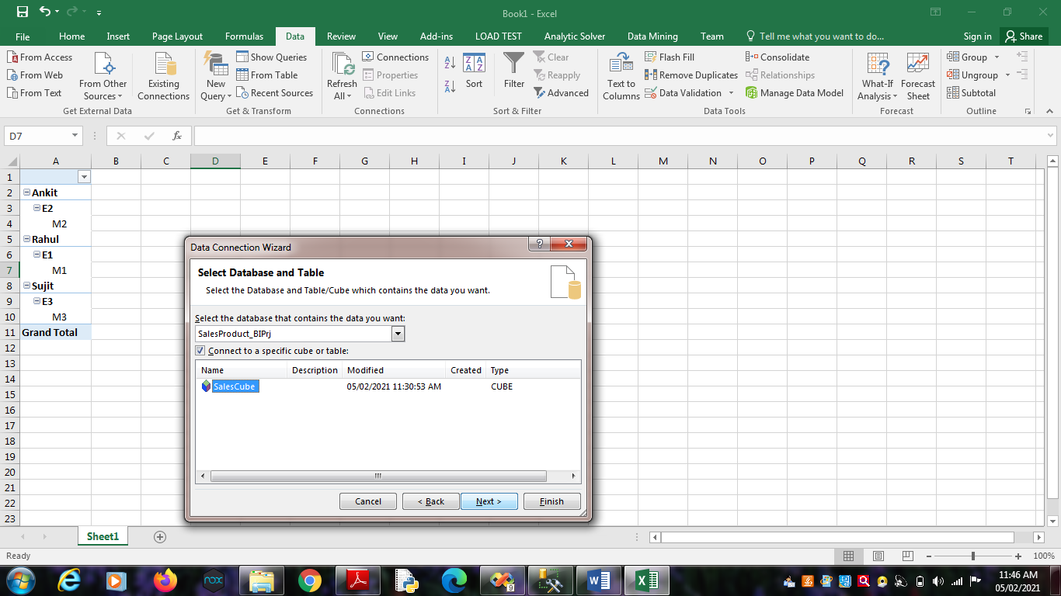

Click on OK.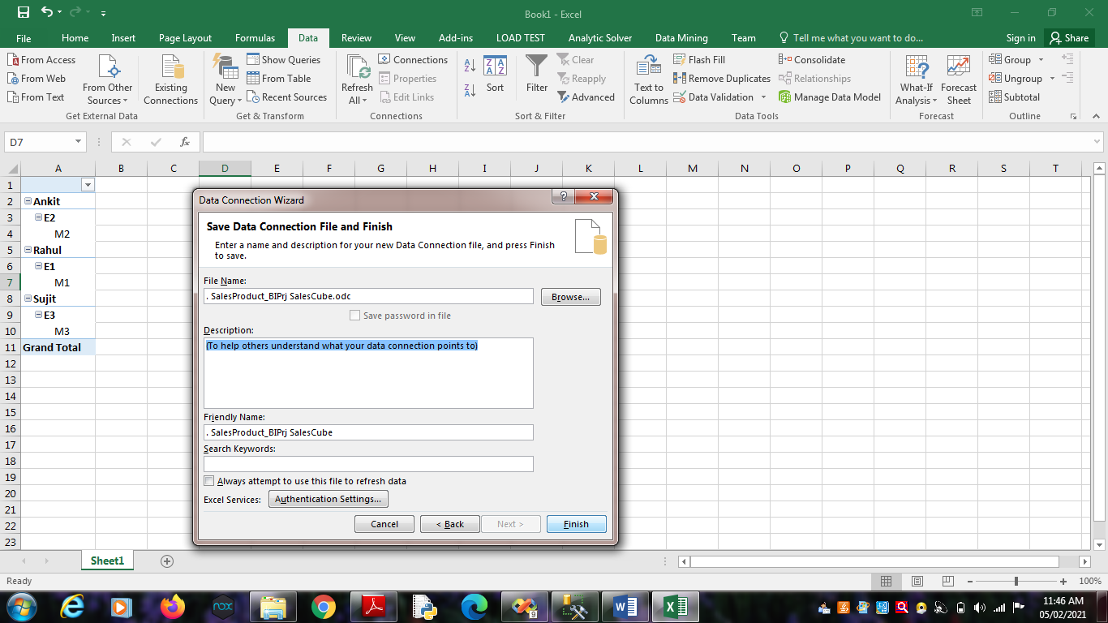

Click on Finish.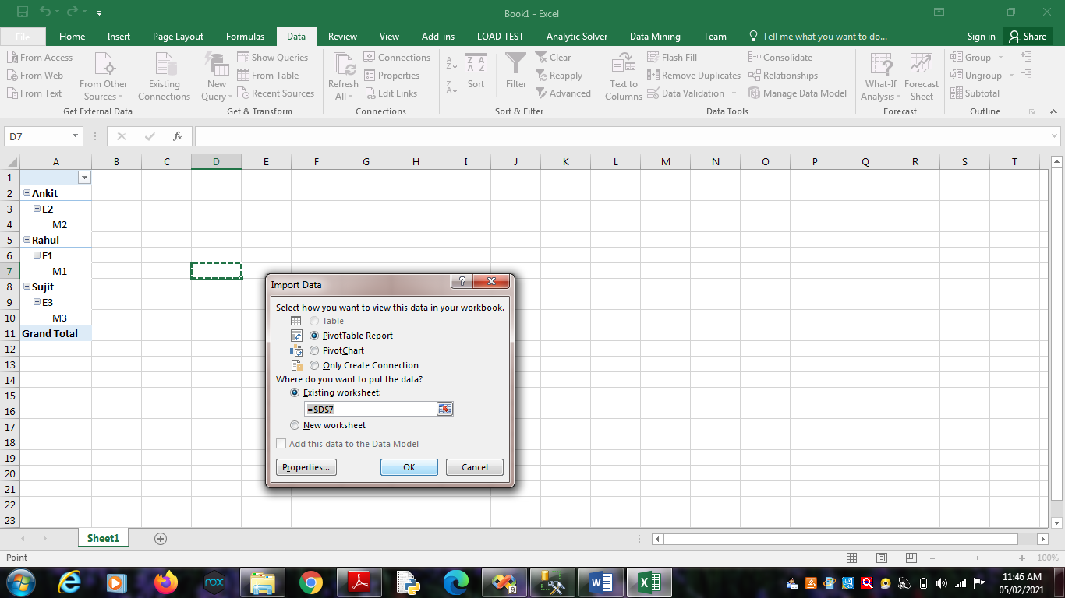

Click on OK.

3. Select State_ID, Product_ID,Employee_ID and Measures as

Sales_Dollars, Sales_Units and Sum Sales Dollars.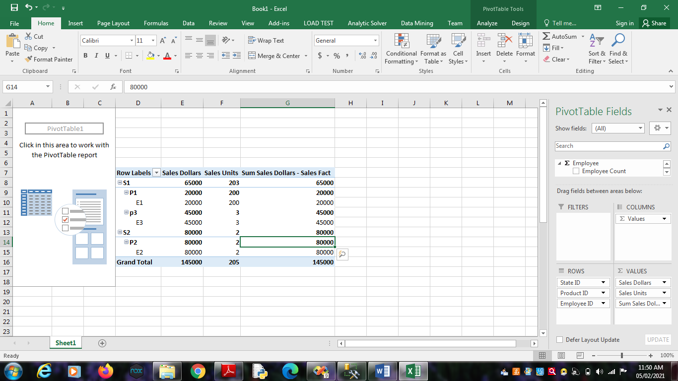

4. Select Result Area. Go to Insert Menu. Select Pie Chart option.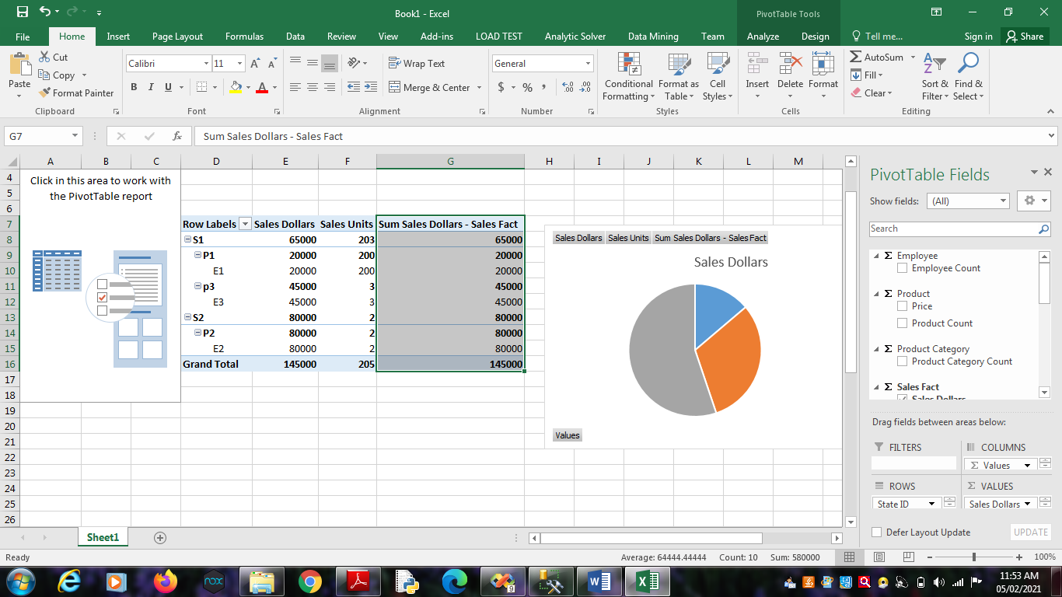

5. Select Result Area. Go to Insert Menu. Select Column option.